Poorvottar Mein Hindi
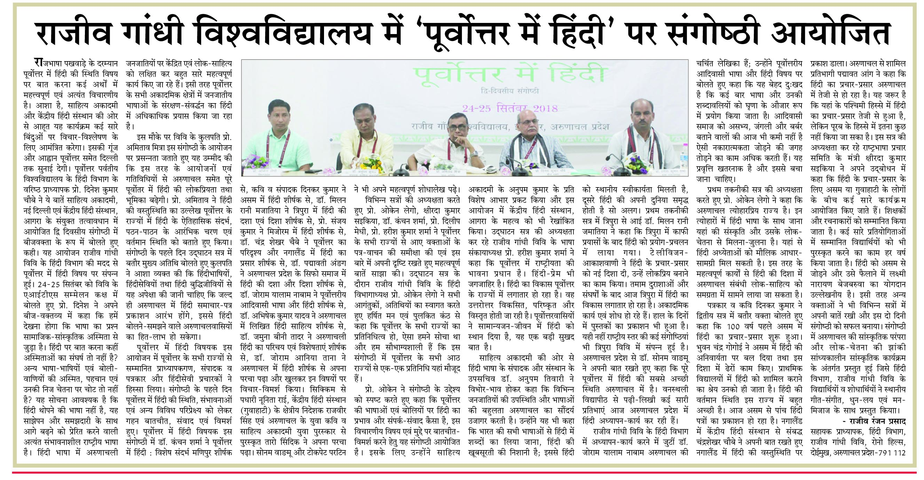
The two-day seminar was convened by Sahitya Akademi and Central Hindi Institute. It was held on 24-25 September, 2018 with the help of Department of Hindi, Rajiv Gandhi University on the subject of ‘Poorvottar Mein Hindi’. Speaking on the topic Prof. Dinesh said in his key address that Hindi is not a language to impose; it is the most promising national language to motivate and move forward with sharing and understanding. Many important works are being done in Hindi language by focusing on the Tribes in Arunachal and their major focus is the folk literature. Similarly, all efforts are being made to increase the conservation of tribal languages through Hindi in all academic areas of the Northeast.
During one of the sessions of the seminar on ‘Poorvottar Mein Hindi’ Dr. Kanchan Sharma presented the paper on the topic ‘Poorvottar Mein Hindi: Vishesh Sandarbh Manipur’, along with her there are some papers which attracted the attention of the audience are the paper presented by a Poet and Editor Dinkar Kumar with the title ‘Assam Mein Hindi’, Dr. Milan Rani Jamatia ‘Tripura Mein Hindi Ki Dasha Evam Disha’, Prof. Sanjay Kumar titled ‘Mizoram Mein Hindi’, Dr. Chandra Shekhar Choubey with the title ‘Poorvottar Ka Paridrishya Aur Nagaland Mein Hindi Ka Prasar’, Dr. Jamuna Beeni Tadar ‘Arunachali Hindi Ka Parichay Evam Vishestayen’, Dr. Abhishek Kumar Yadav with title of ‘Arunachal Mein Likhit Hindi Sahitya’, Dr. Joram Yalam Nabam with the title ‘Poorvotarien Adivasi Bhasha Aur Hindi’, Dr. Joram Aaniya Tana read his paper ‘ Arunachal Mein Hindi’. Nunita Rae from Sikkim, Rajveer Singh, Regional Director, Central Hindi Institute, Guwahati, and Taro Sindik, who was awarded the Young Poet and Sahitya Akademi Yuva Puraskar from Arunachal, also presented their papers. Sonam Wangmu and Tokpet Pertin also read their paper.

